Geometry: Unit 4, Lesson 6

- Rigid transformations are transformations that do not change the size or shape of an object. These include rotations, reflections, and what else?

Translations

- What are two transformations that are isometries?

Reflection and Rotation

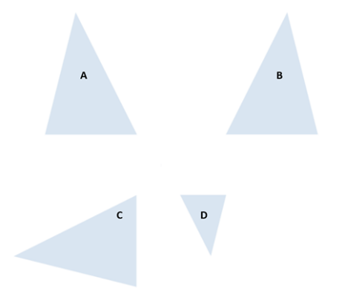
- Which of the transformations of triangle A does not preserve distance and angle measure?

D

